Architecture and zoning

What’s the range of electric vehicle

Fear of lacking charging stations

Several types of charging stations

There are 3 main types of charging stations:

_ level 1 : AC level 120 volts, generally 15 or 20 ampere. It is the cheapest type of charging stations, but requires a lot of time to charge any car. Due to the long charging time (>8h), this type of charging station is mainly used to charge its vehicle overnight, at home.

_ level 2 : AC level 208-240 volts, 40 ampere (80 maximum). This intermediary charging station is a bit more expensive, and can be used in commercial areas, or any other place where the driver will stay a limited but still not too short amount of time. It is expected to fully charge a vehicle in between 4 and 8 hours.

_ level 3 (fast charger) : DC power converted from AC power up to 480 volts. Far more expensive, this charging station enables the driver to charge its car to 80% in 30 minutes.

  

Level 1 EV supply equipment Level 2 EV supply equipment DC fast charger

(doc NYSERDA p3)

Although the plugs for level 1 and level 2 charging stations are the same, the DC fast chargers has currently two different standards for the plugs.

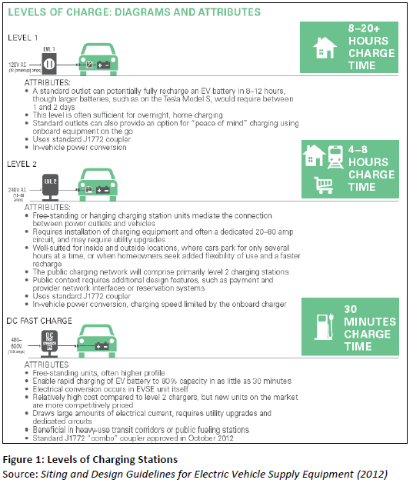

Rules and design to put charging stations

Charging stations need to fit in the current environment, whether it is in private areas (home garage), or public areas (parking spots). At this time, many rules about the design of such charging stations have been implemented; they specify the required size, the security of the charging stations, the minimum number of charging stations in an area. There regulations are more mature in Europe and the US, and we will consider here the US regulations. Although many of these rules are local and depend on the city, we can find the same characteristics.

Design :

_ the charging stations is generally at the front or the sides of the vehicle; what’s more, the user need to be able to operate it, which requires extra place at the front of the vehicle. Extra place on the side should also be arranged to deal with the issue of the cable (a level 2 EV station has a cable of a length around 20 feet). In many high density parking areas, this extra place has not necessarily been taken into account.

 

**Striped pavement designates space to operate EV supply equipment Cables can create tripping hazard**

Account Many DC fast charger are designed differently because they are heavy. But these kinds of design could have an impact on the ergonomics of parking spots. Some parking structures provide opportunities for a more practical and cost-effective design.

 

**Suspending cable assists with handling Ceiling--‐mounted conduit located near wall**

_ in parking facilities, the localization of the charging stations needs to be chosen: is it better to place them near the entrance of the shopping mall (ie among the most frequented places) or a bit further? Near disabled people spots (already designed to be larger) or not?

_ When choosing a place to put the charging station, one need also to take into account the need to connect it to an electrical source. It could be solar panels, but it can also be the public electricity network. In this fashion, the need to trench into the ground to connect the charging stations is also an issue in parking areas.

_ The security of the charging station place concerning the environmental risks is non neglectable. It should not be installed in flooding areas. It should be protected from the shocks of a vehicle for instance, or any other hazards.

 

**Use of wheel stops to prevent vehicles**

**Wall--‐mounted barriers offer an alternative**

**to wheel stops and bollards**

**from damaging EV supply equipment**

Different locations for different purposes

Conclusion:

In this part, many elements should be taken into account :

_ the fear of a desert of charging stations

_ the different size of cities and availability of parking areas

_ the need near the charging stations of electrical infrastructure